**Higantes Festival**

Higantes Festival is an annual festival held in Angono, Rizal when the town comes alive with vibrant colors, vivacious crowds and a sense of belonging for locals.

The festival is held on 22nd and 23rd of every November and was initially scheduled to coincide with the festival of Pope (St.) Clement. The hallmark of this festival has to be the parades of towering giants made of paper-mache, some as tall as fifteen feet. The use of paper mache is a reflection of the town’s artistic streak.

**Higantes Festival Details**

The giants, locally known as Higantes are designed to express a person’s character or a unique idea. According to the locals, this practice began when locals in Angono created a dummy to portray a mean landlord who was best recognized by his foul mannerisms and an imposing height. Locals have since used paper mache following this trend.

Apart from exemplifying the artistic talent in the Angono, the festival also places a strong emphasis on the importance of recycling material and consequently, conserving the environment. As a result of this technique, also known as creative recycling, Higantes Festival has propelled the town to one of the most delightful tourist destinations in Philippines.

Arguably the capital of arts in the country, Angono has continually attracted art lovers from across the country as well as globally. For those who would like to learn more about the higantes, a visit to the popular Blanco Family museum will help you unravel some of the mysteries of this fascinating festival.

Renowned higante-designer, Argana Tori has close to a hundred pieces of the paper mache giants. This allows visitors to indulge in the Higantes Festival with the locals, all the while immersing themselves in the culture of Angono.

**Higantes Festival History**

The Higantes festival is a regular festivity that celebrates a patron saint, just like any other places, cities or town in the Philippines. However, the people of Angono really love to make and throw a big party. That’s why this festival became huge compared to other fiestas that honor a specific saint. It is possibly one of the reasons why It was called Higantes as it is referred to giants and a big party or festivity is what it requires.

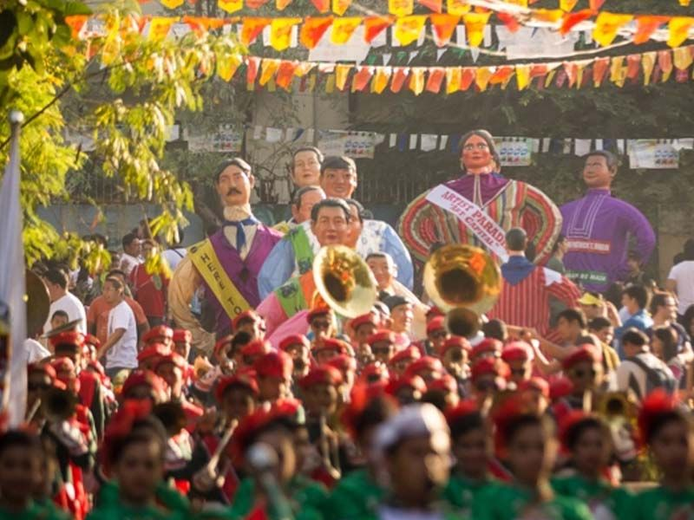

The Higantes fiesta a two-day event scheduled on the 22nd and 23rd of November every year. It doesn’t usually change like most fiestas in the Philippines, it has a fixed date not unless it has been changed or altered by the mayor or the townspeople due to some certain events.

This festival differs from other festivals in the Philippines as its main event is the Procession of the Saint and not some dance competition, singing content or other recreational activities.

People would walk around certain routes from destination to destination, carrying a huge statue that represents the patron saint. The people participating in the procession would be conveyed by what the locals would call “Pharodes”. It is a devoted person of the patron saint and the celebration itself that dresses uniquely using some colorful designs or a simple fisherman’s clothing. The devotees also have some fisherman’s net, traps, paddles, native wooden shoes and other more things that a true local fisherman would wear and have.

Adding some vibrancy to the festival, there is also a statue of giants being carried around made from paper mache measuring about 12 feet in height and about 5 feet in diameter.

Now, when did this all begin?

The word Higantes refers to the giant. It is a Spanish word that Filipino used as the Philippines were under the Spanish regime during the birth of this festival.

It was more than 100 years ago that the Higantes festival was born.

The place of Angono was a very wide hacienda owned by the Spaniards and during that time, there were some financial struggles where different Spanish hacienderos or hacienda owners are becoming short with the cost of so many celebrations in town. They had all thought of cutting some budget short and leave only with one annual celebration of festivities in town.

Filipino people were strong and are very creative. Thinking that all celebrations were taken from them but one, they managed to make the most out of the situation.

Given only one annual celebration, the Filipinos thought of packing so many events and enjoyments in just one fiesta they have. People decided to create huge caricatures of the different landlord to also include and honor them as part of their celebration and sort of a tricky and deceitful inside joke. The caricatures are vibrant with bright and colorful designs.

*Source: expertworldtravel.com*